**Readme - TimeTrac**

1. Download flutter SDK, VS Code, Android Studio
2. The main flutter code can be found in the dart files in the lib folder, To change/add firebase bring changes to the Android Manifest in Android folder, same procedure in the iOS folder for iOS
3. The pubspec yaml file is where plugins are added for [pub.dev](https://pub.dev/) website.

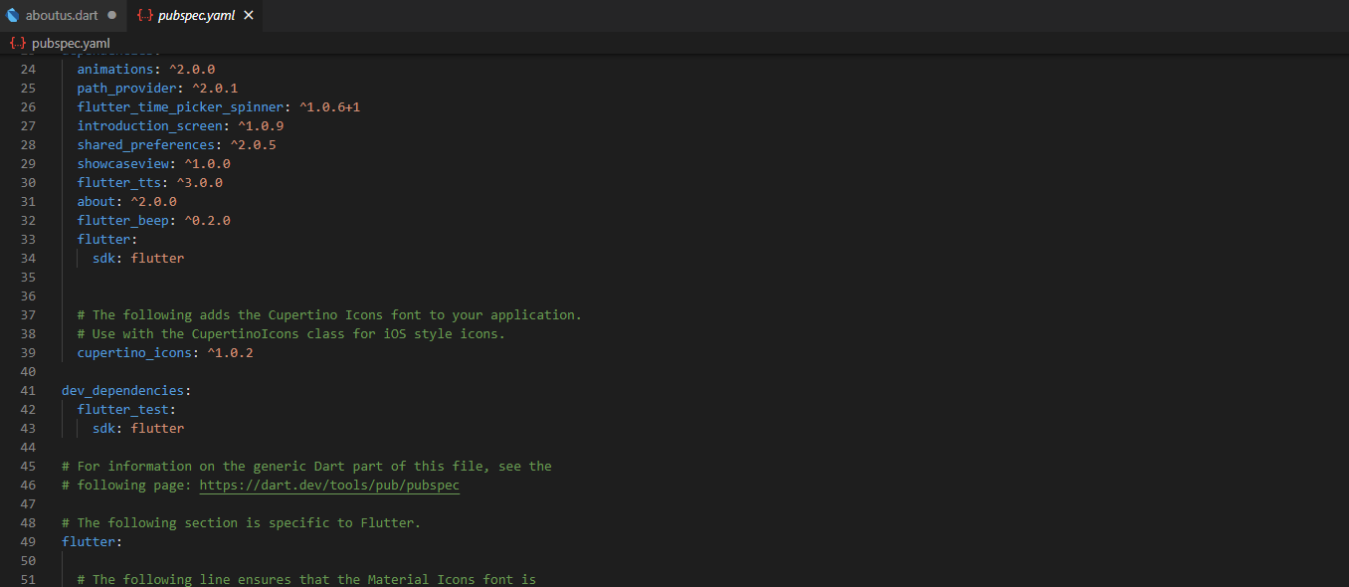

1. To run the code go to lib folder, you can find the main.dart folder and click on f5 or run on top and this either opens the android studio's emulator or if a physical device is connected to PC then it runs there.
2. To create an APK file go to the terminal and type “Flutter build apk”

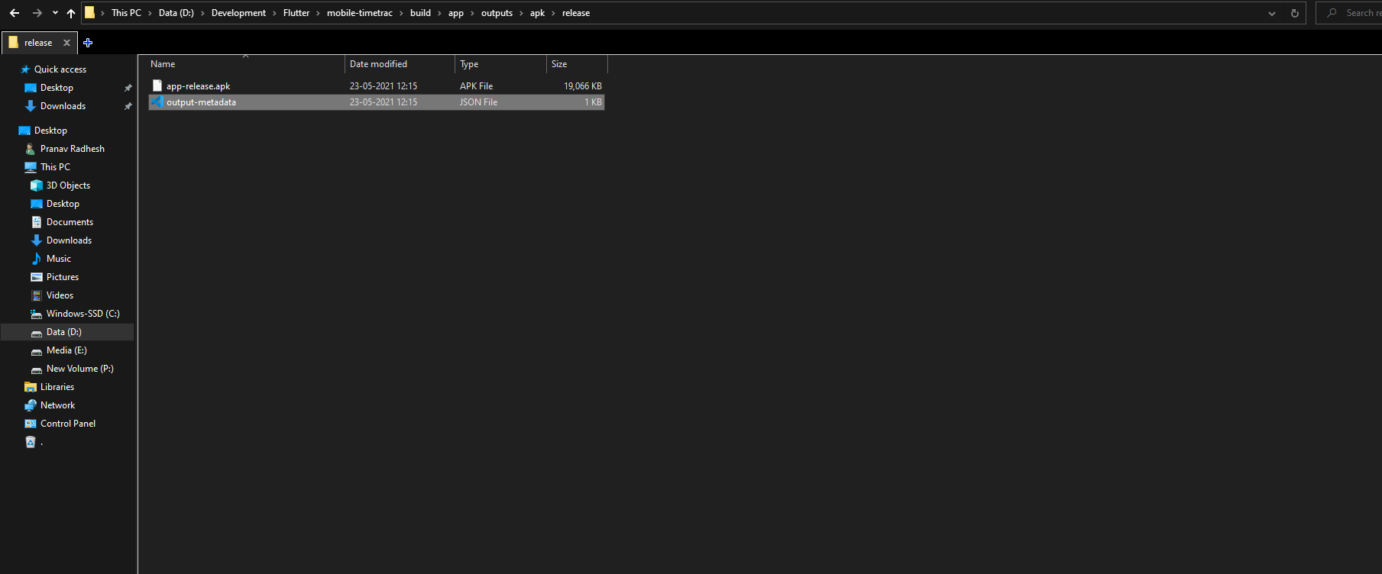

Please revert back to me incase of any concerns or doubts at [pranavradhesh@gmail.com](mailto:pranavradhesh@gmail.com)